FINAL PROJECT REPORT

Name : Faisal Abdul Rafi

Class : IT Class 2

ID : 001201700035

Screenshoot :

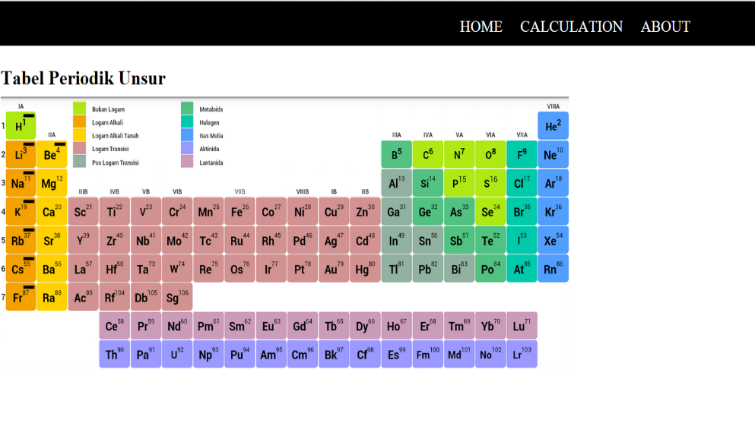

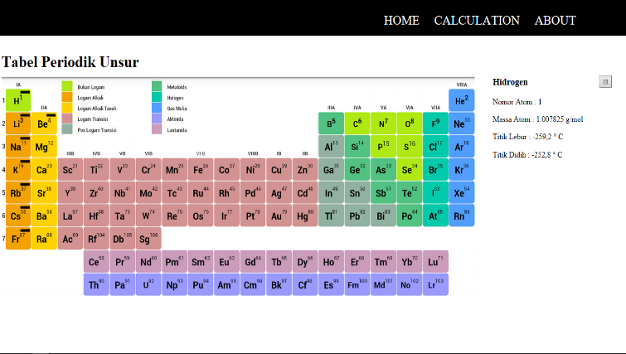 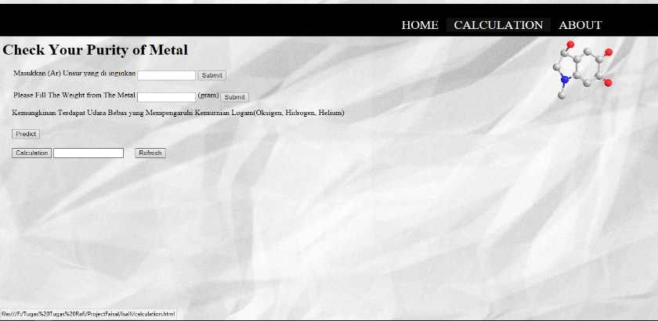

Goal/Problem to Solve :

This app for the student of Science because this goal of this app to make the student easier for learning about science.

Features :

* The Information about all table Periodic.
* Calculation about element of the table periodic.

Implementation Detail :

* Home

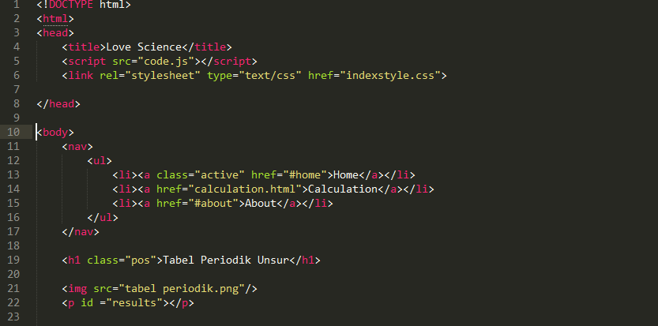

This is for the home code, this code just make html principle, and to show the home page of this app.

And for <nav>,<ul>,<li>,<h1>,<img> this is just element to implemented my page home.

* Show Information By Onclick.

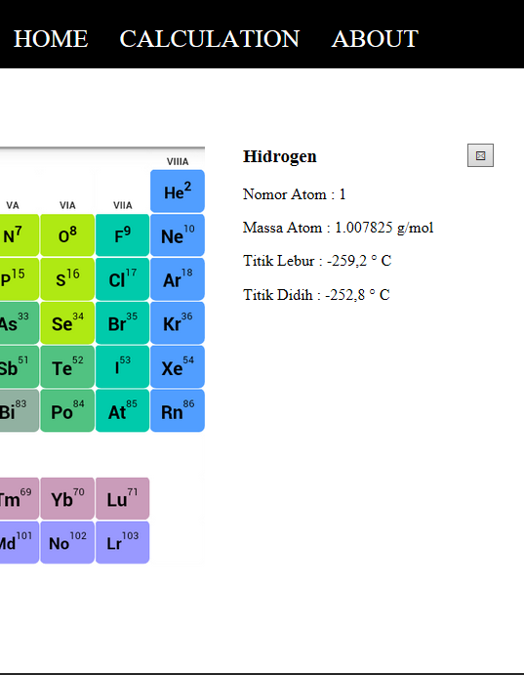

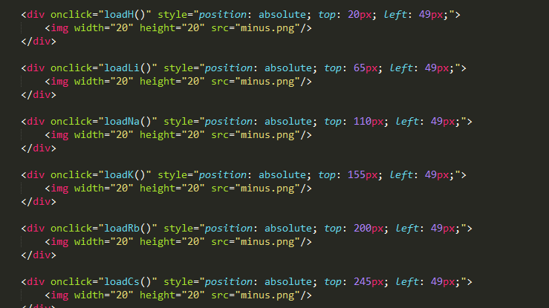

This still on html file, there is Event Generator which is Onclick and there are Event Handler like “loadH(), loadLi(), loadNa(), etc.” and for the other code I just mention css for adding the page.

**<button onclick="tekan()" id="tombol" class="pojok">&#x2612;</button>**

The code above is the same like before code but in this part the Event Handler is different. The event handler is “tekan()” for run a function.

* Code for calculation page.

<div class="edit">

<table style="margin-left: 20px;">

<td>Masukkan (Ar) Unsur yang di inginkan</td>

<td><input type="number" id="atom" size="16" name=""></td>

<td><button onclick="atomsbm()" type="submit" >Submit</button></td>

</table>

<table style="margin-left: 20px;">

<td>Please Fill The Weight from The Metal</td>

<td><input type="number" id="wght" size="16" name="weight"></td>

<td>(gram)</td>

<td><button onclick="wghtsbm()" type="submit" >Submit</button></td>

</table>

<p style="margin-left: 20px;">Kemungkinan Terdapat Udara Bebas yang Mempengaruhi Kemurnian Logam(Oksigen, Hidrogen, Helium)</p>

<button style="margin-left: 20px;" onclick="myFunction()">Predict</button>

<div style="margin-left: 20px;" id="bbs"></div>

<button style="margin-left: 20px;" onclick="calc()" type="submit">Calculation</button>

<td align="center"><input id="hasil"></input></td>

<button style="margin-left: 20px;" onclick="ref()" type="submit">Refresh</button>

<td align="center"></input></td>

</div>

**This code for declare the event generator and event handler for this page which is page calculation. And there are add css code.**

var a=0;

function atomsbm(){

a= document.getElementById("atom").value;

console.log(a);

}

var t=0;

function wghtsbm(){

t= document.getElementById("wght").value;

console.log(t);

}

var x=0;

function myFunction(){

x = Math.floor((Math.random() * 10) + 10);

document.getElementById("bbs").value = x;

document.getElementById("bbs").innerHTML = x + "%";

console.log(x);

}

var total=0;

var qq=t*x;

var ee=qq/(a/100);

function calc(){

qq=t*x;

ee=qq/a;

total = ee*100;

document.getElementById("hasil").value= total + "%";

console.log(total);

}

This code for run the calculation.

var a=0;

function atomsbm(){

a= document.getElementById("atom").value;

console.log(a);

}

There is some function the name of function is “atomsbm()” a is the variable of this function to declare the user input in function “a”.

The “document.getElementById("atom").value;” this code to get the value from the user input. And “atom” for to know the input will be declare as a id. “console.log(a);” this code just for to know when the page want to run. And For debugging purposes, you can use the **console.log()** method to display data.

x = Math.floor((Math.random() * 10) + 10);

document.getElementById("bbs").value = x;

document.getElementById("bbs").innerHTML = x + "%";

console.log(x);

}

Math.random() used with Math.floor() can be used to return random integers. And for (*10) + 10 this for use math random max number is 20. And “Math.floor()” for rounded down.

* Function refresh value page calculation

function ref(){

document.getElementById('atom').value= " ";

document.getElementById('wght').value = " ";

document.getElementById('hasil').value = " ";

document.getElementById("bbs").innerHTML = " ";

}

This code to refresh the value of id below. The value will be disappear because I change the value of this function (value = “ ”).

* Function for show the information from each unsur

function loadH() {

document.getElementById("tombol").style.opacity ="1";

var xhttp = new XMLHttpRequest();

xhttp.onreadystatechange = function() {

if (this.readyState == 4 && this.status == 200) {

document.getElementById("hid").innerHTML =

this.responseText;

}

};

xhttp.open("GET", "hidrogen.txt", true);

xhttp.send();

}

I take one of the unsur of table periodic. This code is to called ajax function so this code will take “hidrogen.txt” in the same file. And will be print on the id that I declare in this function which is “document.getElementById("hid").innerHTML =

this.responseText;”

document.getElementById("tombol").style.opacity ="1";

This code for show the id “tombol” and print in this page because the (.style.opacity ="1";) opacity has change.

Future Work :

1. For the future of this application is made for students. Especially science student in order to learn more effectively in memorizing the formula.
2. In one web the student can get information about the formula. For now the student just can look the formula of chemistry but maybe in the future can be add. And will be show the formula of math, the formula of physics, or maybe to memorize biology.